**Mockito Hands-On Exercises**

**Exercise 1: Mocking and Stubbing**  
**Scenario:**  
You need to test a service that depends on an external API. Use Mockito to mock the external API and stub its methods.

**Steps:**

1. Create a mock object for the external API.
2. Stub the methods to return predefined values.
3. Write a test case that uses the mock object.

**SOLUTION:**

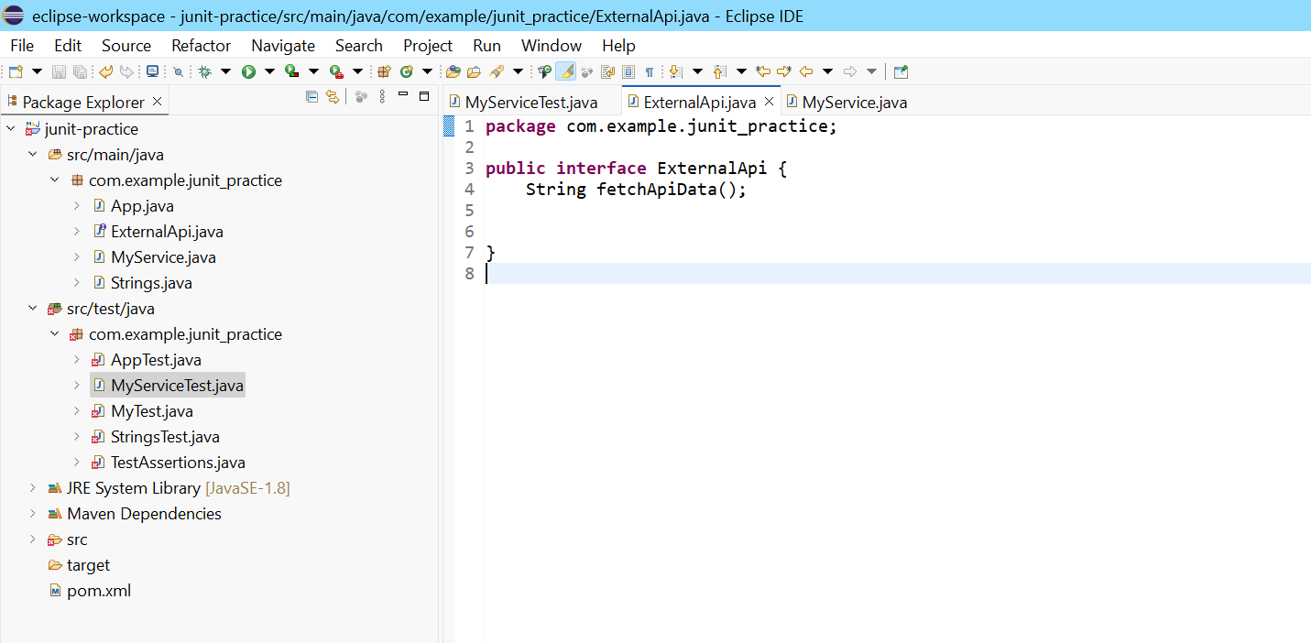

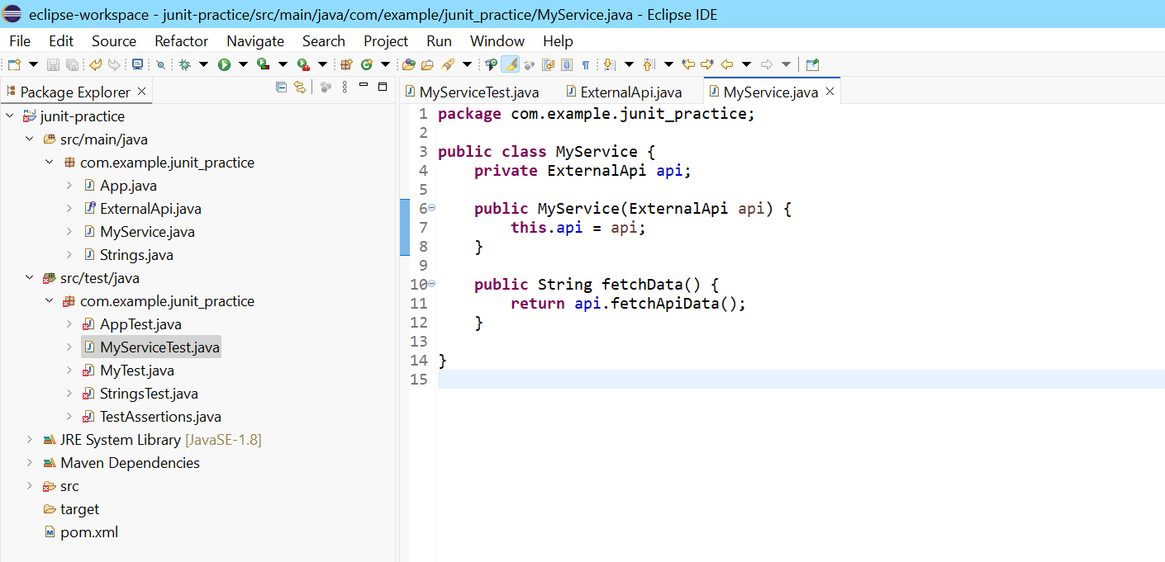

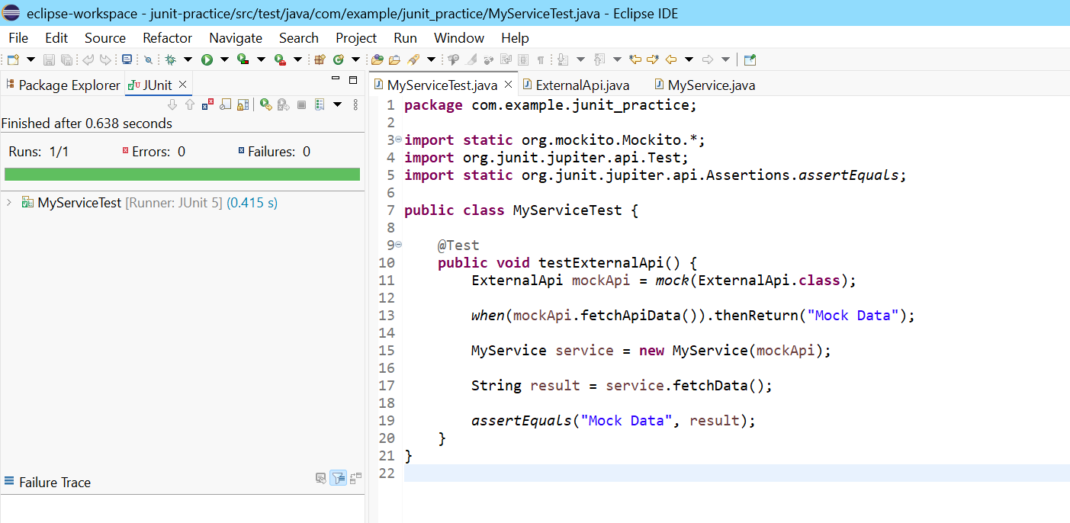

**Exercise 2: Verifying Interactions**  
**Scenario:**  
You need to ensure that a method is called with specific arguments.

**Steps:**

1. Create a mock object.
2. Call the method with specific arguments.
3. Verify the interaction.

**SOLUTION:**

